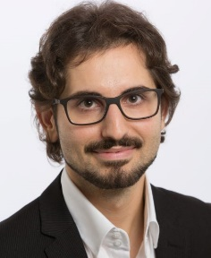**MARCO ROSSI**

**Full-Stack Web Developer**

+39 300 00000 [marcorossi@gmail.com](mailto:marcorossi@gmail.com) Trieste (Italy)

Date of birth: July 10, 2000 Nationality: Italian Driving license: B (with own car)

LinkedIn: link GitHub: link Website: link

**SUMMARY**

Proactive, versatile, and team player are the best words to describe me. I like solving problems and developing efficient databases and intuitive interfaces. My strength is the ability to manage both the back-end and front-end parts of web projects. I use HTML, CSS, JavaScript, Angular, PHP, and My SQL.

Moreover, as a past IT sales representative, I can communicate and interact effectively with clients, and work under pressure.

I want to develop my IT skills, work for an innovative company, and contribute to the growth of your business.

**WORK EXPERIENCE**

IT sales representative, ABC Ltd, Trieste, September 2020 – September 2021

* Responsible for acquiring new clients, conducting sales presentations and negotiations.
* I have acquired 15 new B2B clients and increased sales by 20% in one year.

**EDUCATION AND TRAINING**

* Back-end developer certificate, EPICODE, Rome (Italy), May 2022.
* High school diploma, Scientific Lyceum “G. Galilei”, Trieste, July 2019.

**LANGUAGES**

* Italian: native speaker
* English: advanced level (C1)
* Spanish: pre-intermediate level (B1)

**IT SKILLS**

* MS Office
* HTML
* CSS
* JavaScript
* Angular
* PHP
* MySQL

I hereby authorize the use of my data in accordance with the GDPR 679/16 - European regulation on the protection of personal data.